**TEAM ID:PNT2022TMD23510**

Smart Farmer-IOT Enabled Smart Farming Application

**SPRINT DELIVERY – 3**

# Configuration of Node-Red to send commands to IBM cloud

Ibm Iot out node I used to send data from Node-Red to IBM Watson device. So, after adding it to the flow we need to configure it with credentials of our Watson device.

Here we add two buttons in UI

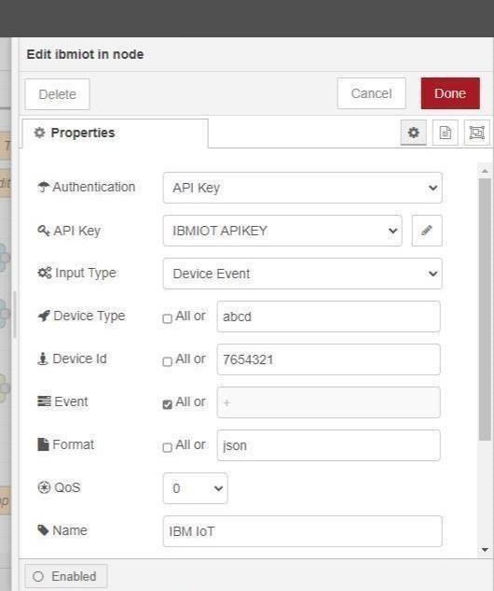

1 -> for motor on 2 -> for motor off

We used a function node toanalyses thedata received and assign command toeachnumber. The Java script code for the analyses is:

if(msg.payload===1) msg.payload={"command”: “ON"}; else if(msg.payload===0) msg.payload={"command”: “OFF"};

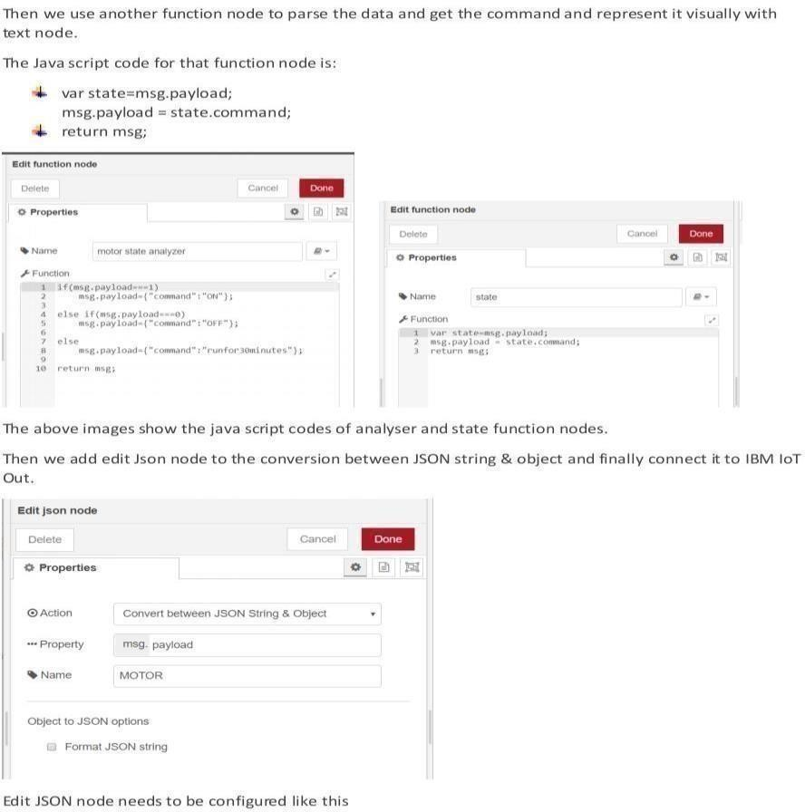

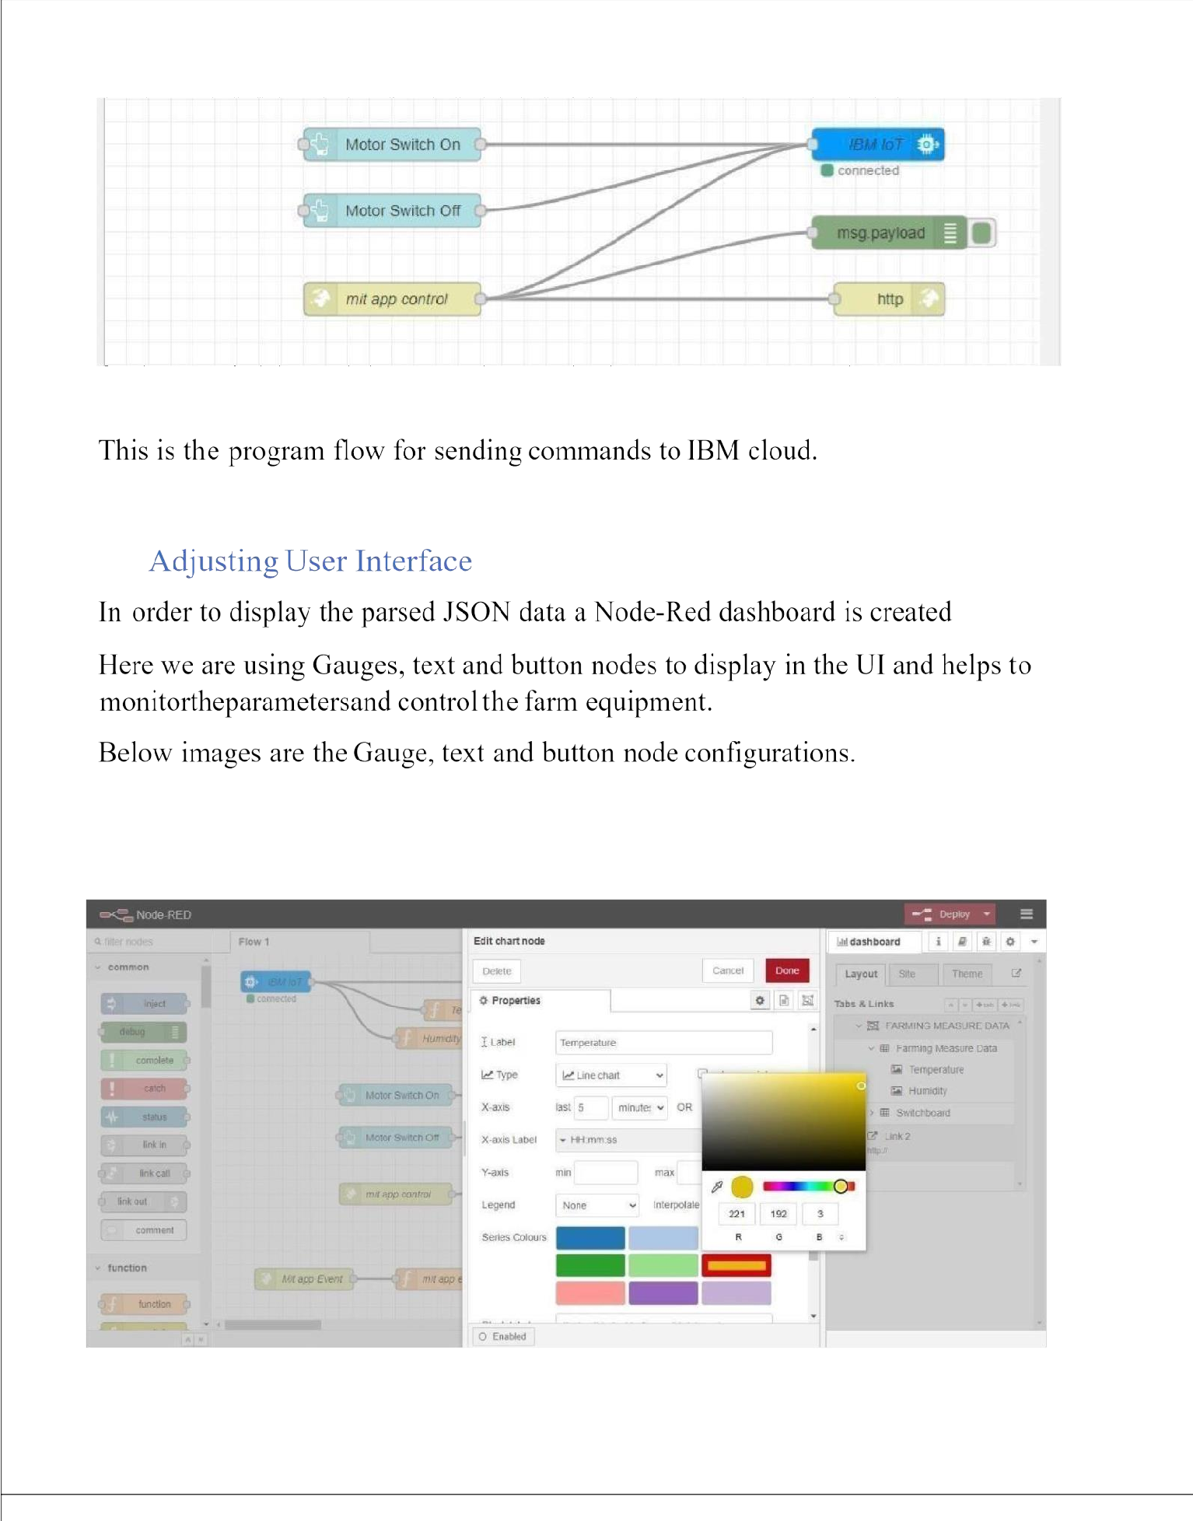

## CompleteProgram Flow

MOBILE APP WEB :

**BLOCK DIAGRAM**

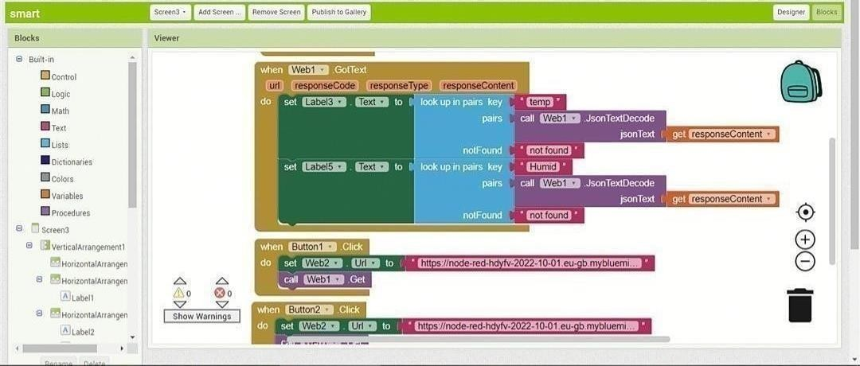

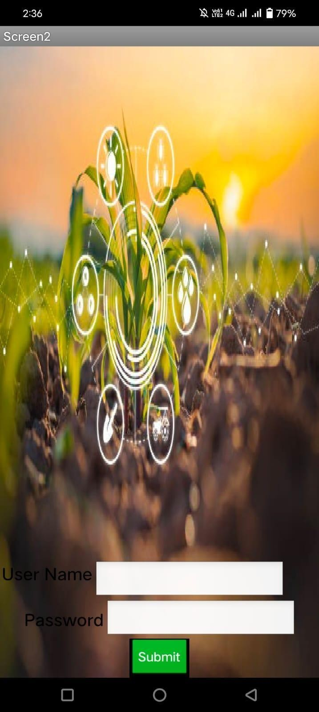

SCREEN – 1 SCREEN-2



SCREEN - 3 SCREEN-4

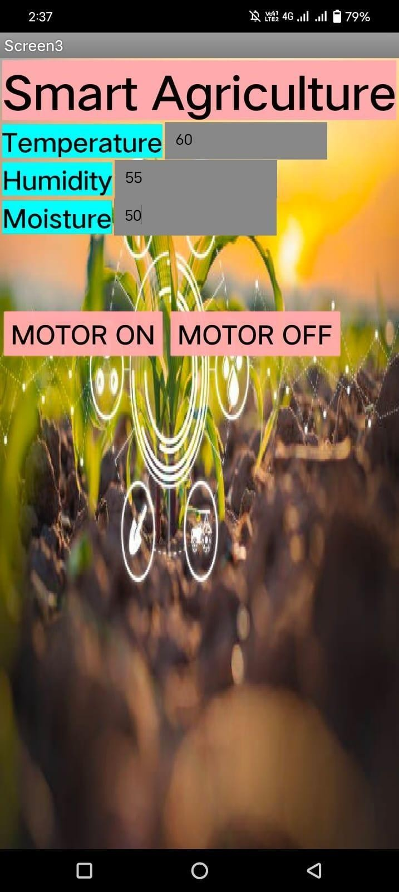

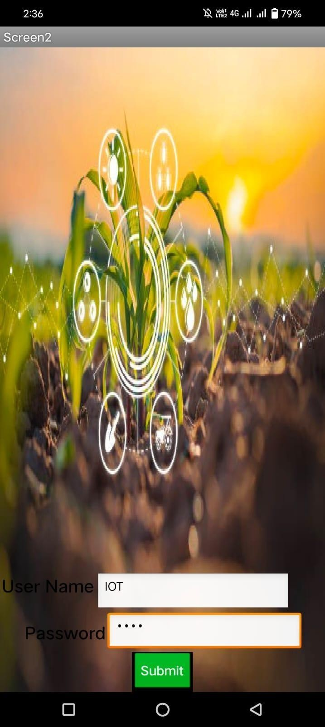

## Web APP UI Home Tab

